**Question -1 Write a program which takes the month number as an input and display number of days in that month.**

**Ans.**

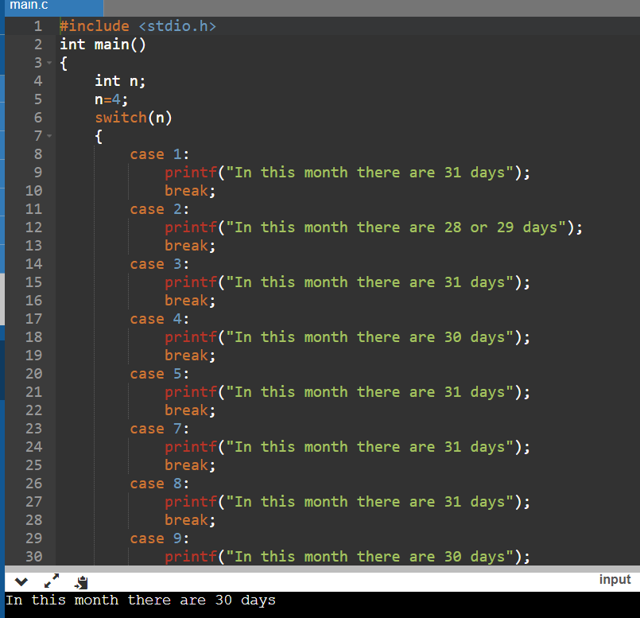

**Question – 2 Write a menu driven program with the following options:**

**a. Addition**

**b. Subtraction**

**c. Multiplication**

**d. Division**

**e. Exit**

**Ans.**

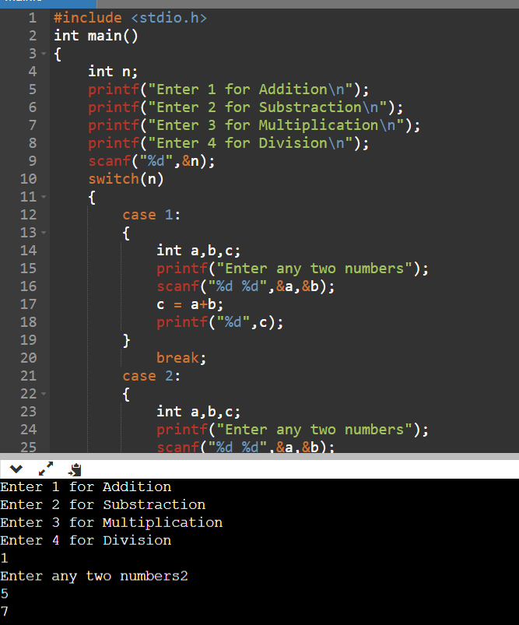

**Question – 3 Write a program which takes the day number of a week and displays a unique greeting message for the day.**

**Ans.**

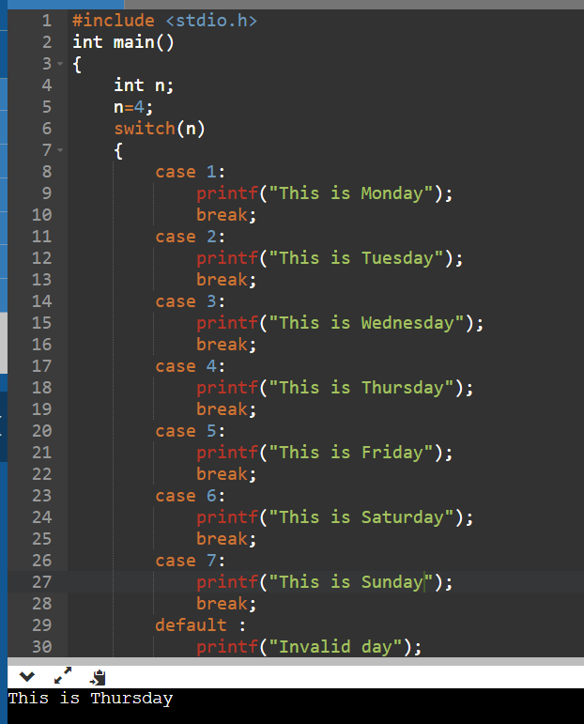

**Question – 4 Write a menu driven program with the following options:**

**a. Check whether a given set of three numbers are lengths of an**

**isosceles triangle or not**

**b. Check whether a given set of three numbers are lengths of sides of**

**a right angled triangle or not**

**c. Check whether a given set of three numbers are equilateral triangle**

**or not**

**d. Exit**

**Ans.**

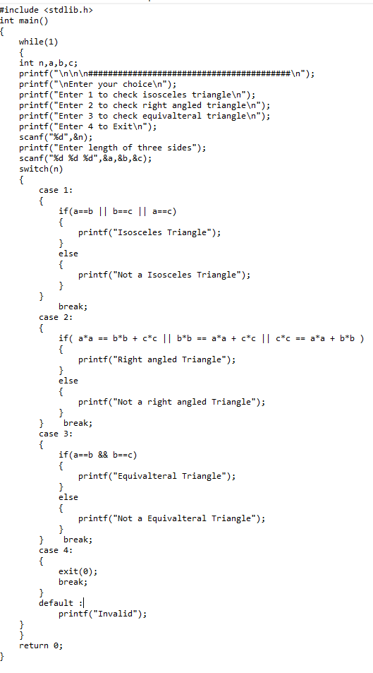

**Question – 5 Convert the following if-else-if construct into switch case:**

**if(var == 1)**

**System.out.println("good");**

**else if(var == 2)**

**System.out.println("better");**

**else if(var == 3)**

**System.out.println("best");**

**else**

**System.out.println("invalid");**

**Ans.**

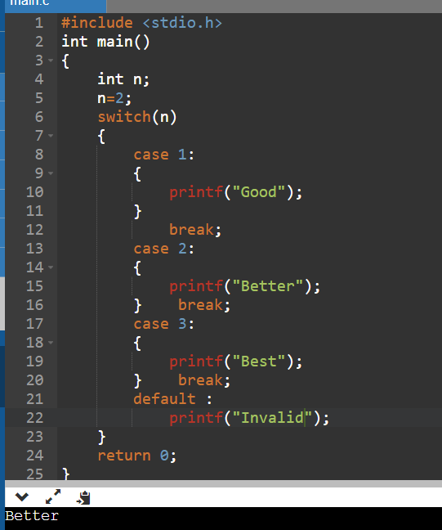

**Question – 6 Program to check whether a year is a leap year or not. Using switch statement.**

**Ans.**

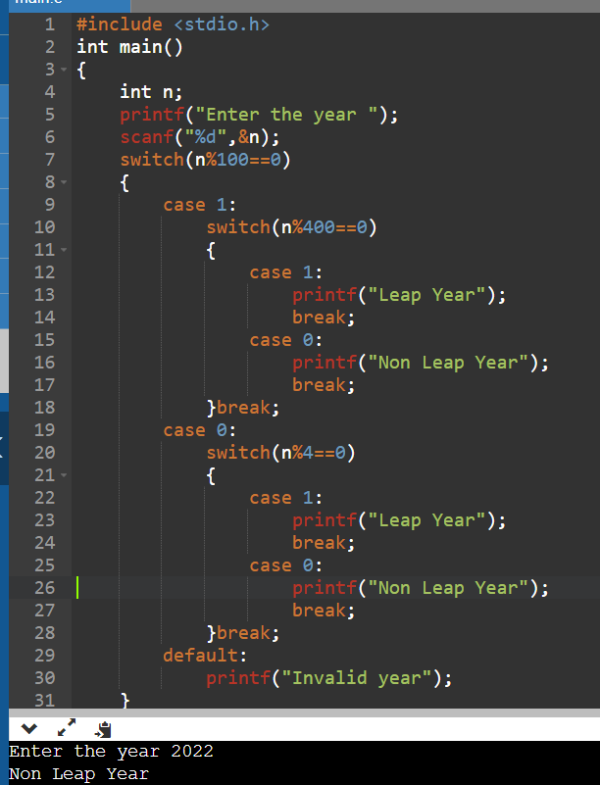

**Question – 7 Program to take the value from the user as input electricity unit charges**

**and calculate total electricity bill according to the given condition . Using**

**the switch statement.**

**For the first 50 units Rs. 0.50/unit**

**For the next 100 units Rs. 0.75/unit**

**For the next 100 units Rs. 1.20/unit**

**For units above 250 Rs. 1.50/unit**

**An additional surcharge of 20% is added to the bill.**

**Ans.**

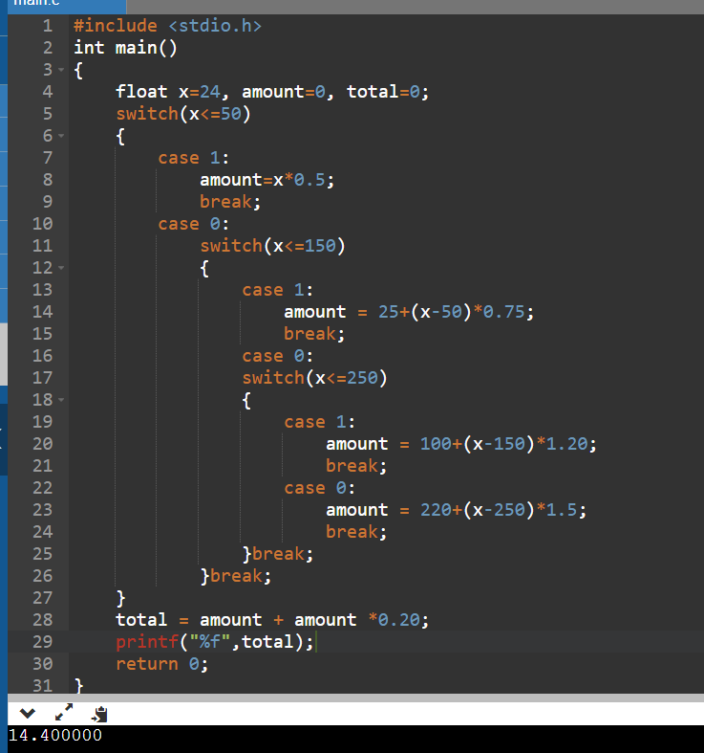

**Question – 8 Program to convert a positive number into a negative number and negative number into a positive number using a switch statement.**

**Ans.**

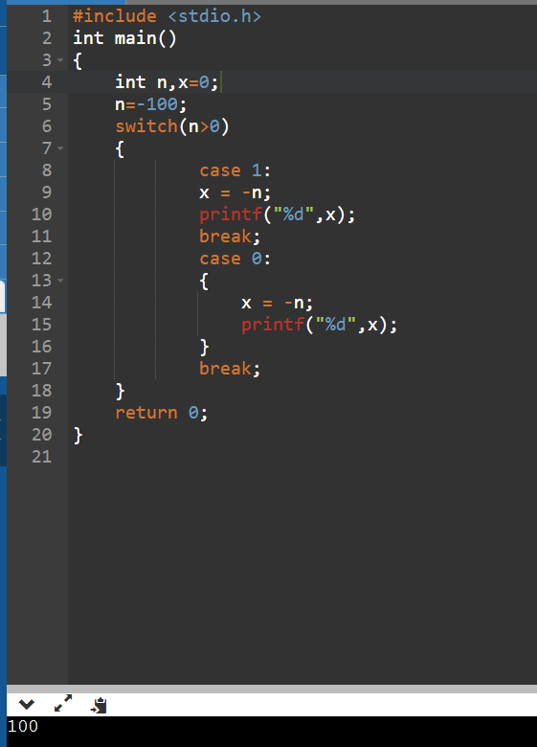

**Question – 10 Program to Convert even number into its upper nearest odd number using switch Statement.**

**Ans.**

